Harmony Elementary Relay for Life 2018 T-shirt order form
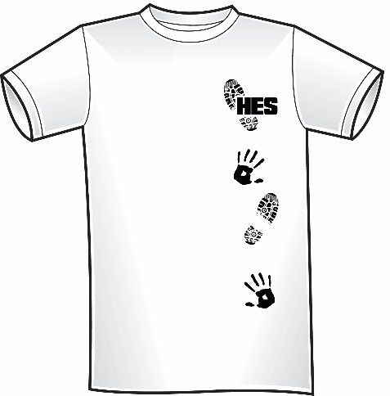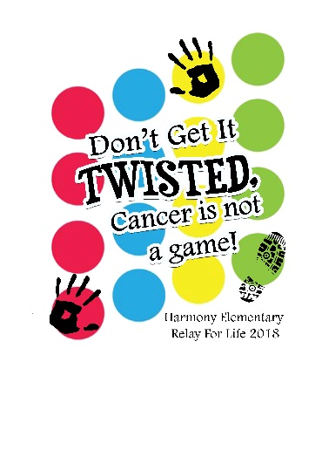
Front (Black lettering) Back (Colored Twister Board)
*T-shirts will be White*
*T-shirts must be ordered and paid for in advance*
All order forms must be in no later than March 29, 2018!
Cash Only Please
(Please circle) Youth: XS S M L XL ($10.00)
Adult: S M L XL ($12.00)
Adult 2X, 3X, 4X ($14.00)
Name of Student ______________________
Teacher_____________ Grade _______
Total: _________________

